28-07-2021

CN LAB - AWS

**PROGRAM** - To find the sum of natural numbers upto the given input “n”

**CODE** :

//sum of natural numbers upto n

#include<stdio.h>

int main()

{

int i,arr[50],n,sum;

printf("Enter a number");

scanf("%d",&n);

for(i=0;i<=n;i++)

{

sum=sum+i;

}

printf("The sum of natural numbers upto %d is %d",n,sum);

return 0;

}

**SCREENSHOT OF AWS (INPUT AND OUTPUT) :**

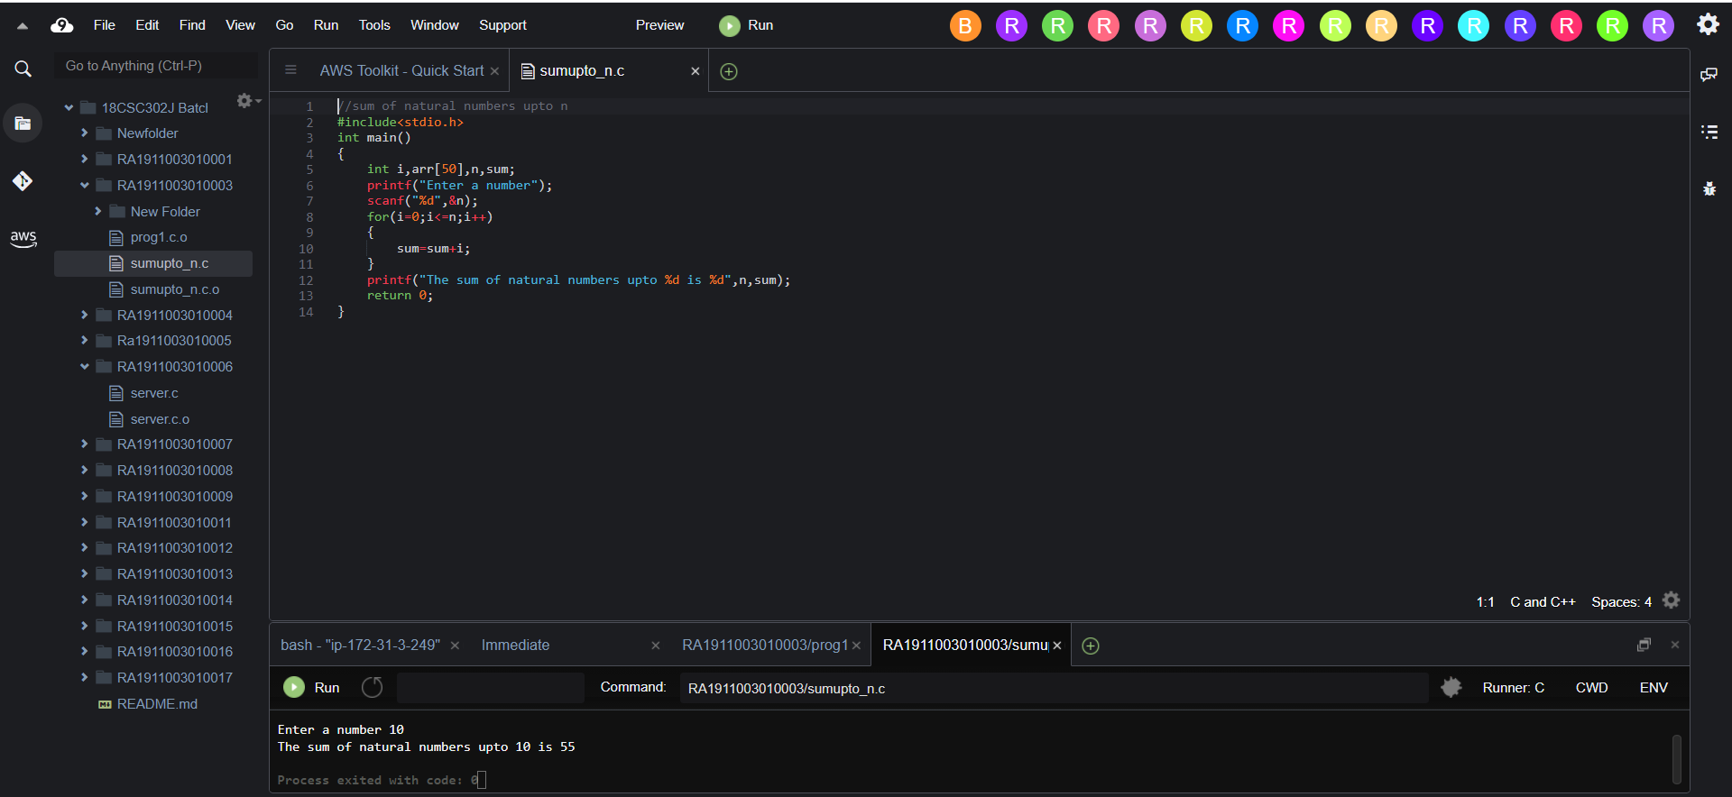

DONE BY :

ABHINAV RANJAN

RA1911003010003

CSE A1 SECTION

SRMIST KTR